CERTIFICATE OF COMPLETION

Type Name Here
OSHA

March 8, 2021
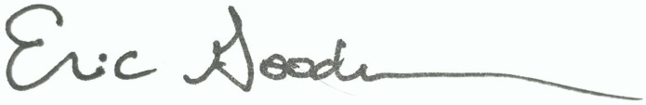

_____________________________________________________________________
Dr. Eric Goodman, Vice President of Education

